Making Tutoring Appointments Using Trac Cloud

Navigate to My Missouri State dashboard > Student Success Resources Card> TracCloud link. You will be taken to the TracCloud dashboard shown below.
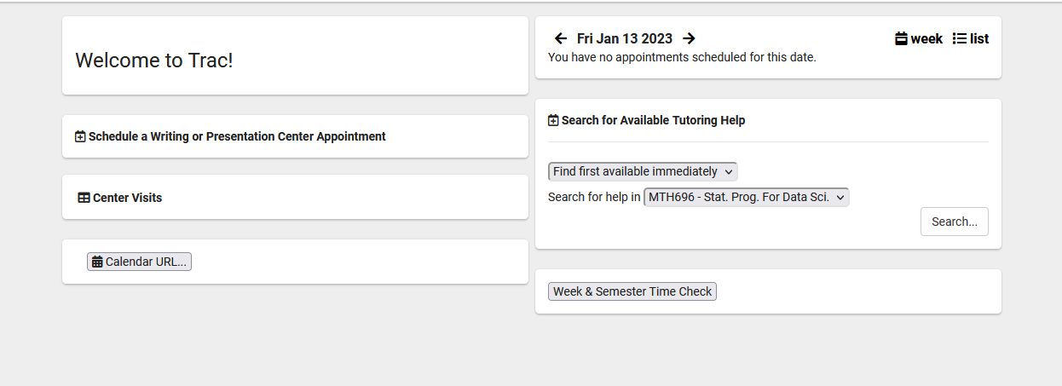

To Schedule a Writing Center, Presentation Center or Tutoring appointment:

- “Find first available immediately” is the default setting. To select a different date range, use the drop-down menu. Note that only available appointments within a 4 day range will appear. Tuesday would be the first day of the week to schedule a Saturday appointment.
- The “Search for help in” drop-down menu will contain the student’s classes. Select a class to search for help in.
- Click Search.

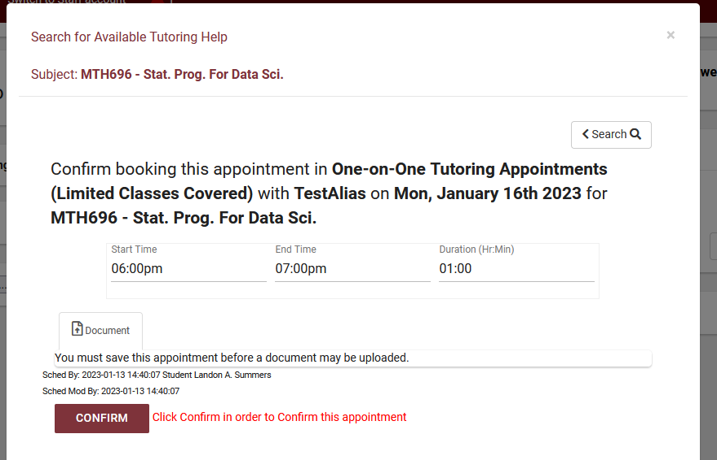
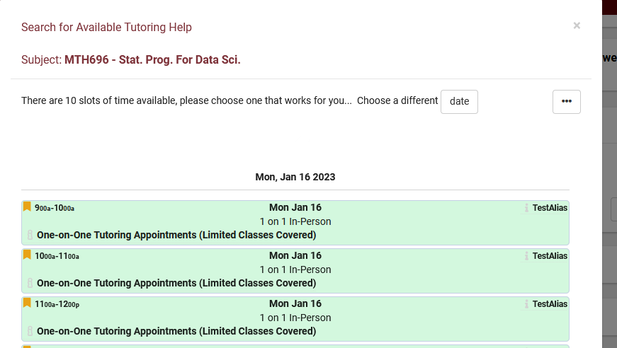
Available bookable slots will be displayed. Click on the desired slot to book an appointment.

Click confirm to save appointment.

Writing Center & Presentation Center
- Book up to 7 days in advance.
- For same-day appointments or walk-ins, please visit the Bear CLAW front desk.
- Up to 1 (one-hour) appointment per day.
Tutoring Appointments
- Book up to 4 days in advance. Must book at least 24 hours in advance.
- Up to 2 (one-hour) appointments per class, per week.
- Please keep in mind that much of the Bear CLAW’s tutoring is done via drop-in tables (Math, Science, Economics and Business). For these subjects, no appointment is needed! Just come in when the table is open and check in at the kiosk near the front desk. Table schedules available at https://bearclaw.missouristate.edu/

